# MED D - Using the Enrollment Portal to Search for Enrollment Applications

General Information

Process

Related Documents

**Description:** This document outlines how to use the Enrollment Portal to search for an enrollment application.

|  |
| --- |
| General Information |

When a beneficiary contacts Customer Care for any issue, the Med D Customer Care Representative (CCR) should always verify the beneficiary’s eligibility before attempting to resolve the issue.

When attempting to verify eligibility the CCR should utilize **ALL** of his/her available resources in researching the beneficiary’s eligibility.

Eligibility information is retained in multiple systems, including:

**PeopleSafe MED D Tab**

**FAZAL**

**Enrollment Portal**

**MARx** (may require SRT assistance)

Top of the Document

|  |
| --- |
| Process |

**Note:** It is important to access and research systems in the following order when attempting to locate an enrollment.

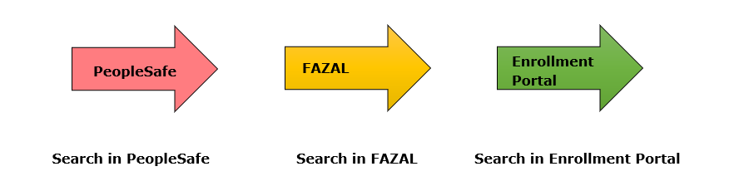

The CCR will follow the steps below after researching the **PeopleSafe** and **FAZAL** systems:

|  |  |  |
| --- | --- | --- |
| **Step** | **Action** | |
|  | Access the Enrollment Portal at <https://www.enrollmentportals.com/Auth/Login.aspx?insCo=ssi>. | |
|  | Log into the Enrollment Portal using the same Username and Password for your computer login. | |
|  | Click the **Reports** drop down and select **Enrollment Search**.  **Result:** The **Search Enrollments Screen** will display. | |
|  | Complete the fields on the Search Enrollments screen.   * Enter the appropriate **Search Criteria** in the box to search for an application. * Select the Filter drop down menu item that matches your criteria or use **All**. The following search criteria are available:   + Medicare number (MBI)   + Name   + CUID (Member ID)   + Phone   + Zip   + AgentID   + **All**   **Note:** It is best practice to use the Medicare Beneficiary Identifier number (MBI) when available.   * Ensure that the drop down menus for **Status** and **Lead Type** are set to **All**. * Use the default **Start Date** and **End Date** or set a custom range, as appropriate. | |
|  | Select **Search**.  **Result:** All available enrollment applications located in the **Enrollment Portal** will be returned in a table below the search button for the beneficiary. | |
| **If…** | **Then…** |
| Application(s) is found in portal with **SENT** status | Refer to the **Effective Date, Plan Type,** and **Status**. View the application information by clicking the **PDF** link under the **Action** header. |
| Application is found in portal with **PENDING** status | Submit an **RM Task** in PeopleSafe and mark as **Urgent:**  **Task Category:** Med D Enrollment - Enrollment  **Task Typ**e**:** Enrollment Not Found in FAZAL  **Queue:**  Med D Enrollment Task  **Notes:** Include the following:   * Document that enrollment application was found in FAZAL with PENDING status * Beneficiary Name * DOB * MBI * Contact Number * Any additional information provided by the beneficiary related to their call   **Note:** If enrollment is for an EGWP client, review CIF for more information. |
| If **NO APPLICATION** found for the beneficiary | Transfer to an Enrollment Agent. Refer to MED D - Guide to Transferring a Call. |

Top of the Document

|  |
| --- |
| Related Documents |

MED D - SilverScript - Real Time Resolution of Eligibility

Grievance Standard Verbiage (for use in Discussion with Beneficiary) section in MED D - Grievances Index

**Parent SOP:** CALL-0048: [Medicare Part D Customer Care Call Center Requirements-CVS Caremark Part D Services, L.L.C.](https://policy.corp.cvscaremark.com/pnp/faces/SecureDocRenderer?documentId=CALL-0048&uid=pnpdev1)

**Abbreviations/Definitions:** Abbreviations / Definitions

Top of the Document

Not to Be Reproduced or Disclosed to Others without Prior Written Approval

**ELECTRONIC DATA = OFFICIAL VERSION - PAPER COPY = INFORMATIONAL ONLY**